LIBRARY MANAGEMENT SYSTEM SQL ANALYSIS

Data Modeling

ALTER TABLE issued_status

ADD CONSTRAINT fk_members

FOREIGN KEY (issued_member_id)

REFERENCES members (member_id);

ALTER TABLE issued_status

ADD CONSTRAINT fk_books

FOREIGN KEY (issued_book_isbn)

REFERENCES books (isbn);

ALTER TABLE issued_status

ADD CONSTRAINT fk_employees

FOREIGN KEY (issued_emp_id)

REFERENCES employees (emp_id);

ALTER TABLE employees

ADD CONSTRAINT fk_branch

FOREIGN KEY (branch_id)

REFERENCES branch (branch_id);

ALTER TABLE return_status

ADD CONSTRAINT fk_issued_status

FOREIGN KEY (issued_id)

REFERENCES issued_status(issued_id);

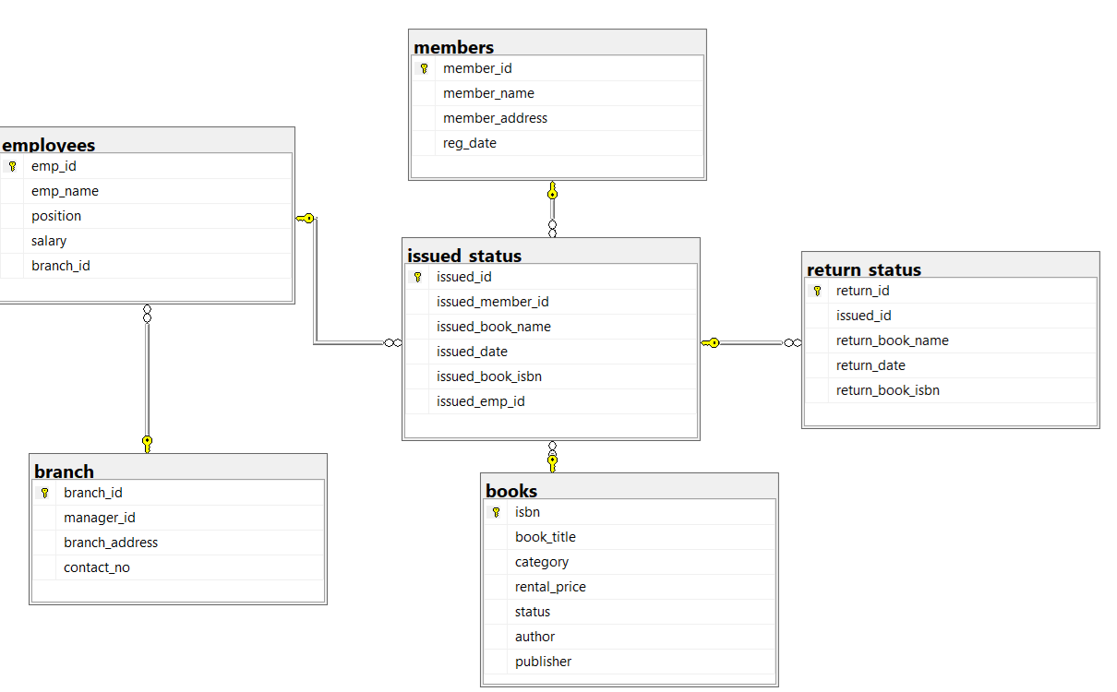

-- While solving above query I got this error

The ALTER TABLE statement conflicted with the FOREIGN KEY constraint "fk_issued_status". The conflict occurred in database "Library_Project_DB", table "dbo.issued_status", column 'issued_id'

Then We found there are return_status.issued_id are not present in issued_status.issued_id so I removed it by Delete query as done below

SELECT issued_id

FROM return_status

WHERE issued_id NOT IN (SELECT issued_id FROM issued_status);

DELETE FROM return_status

WHERE issued_id NOT IN (SELECT issued_id FROM issued_status);

SELECT * FROM branch

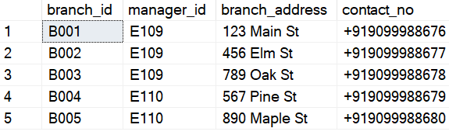

SELECT * FROM books

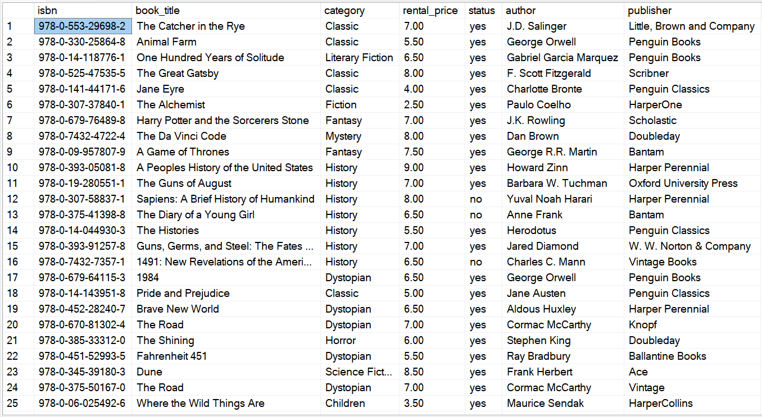

SELECT * FROM employees

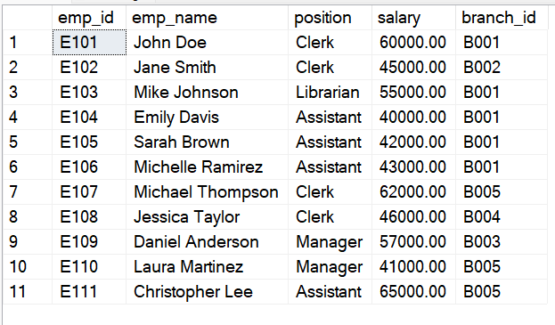

SELECT * FROM members

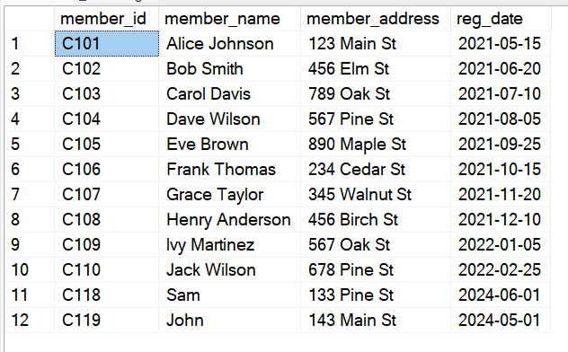

SELECT * FROM return_status;

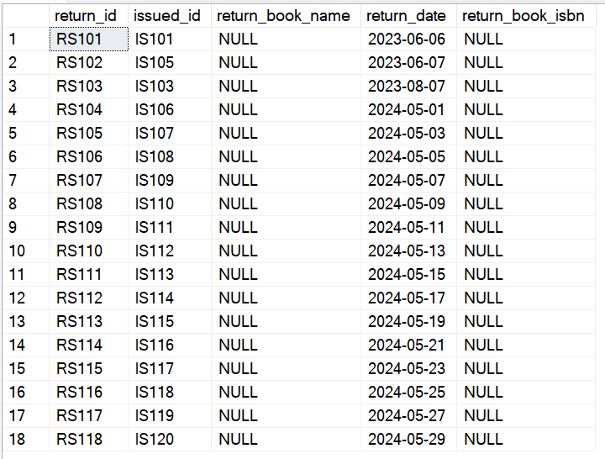

SELECT * FROM issued_status

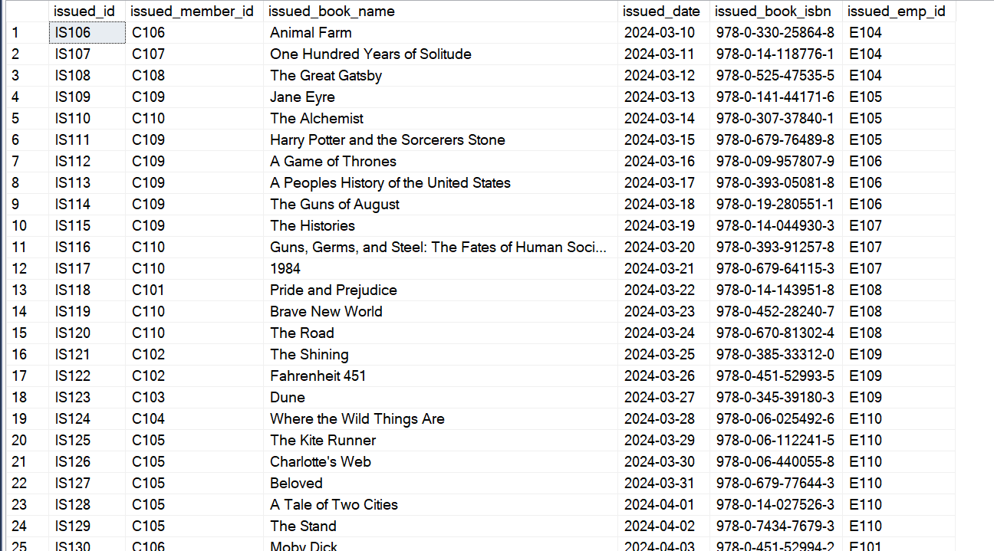

**Project TASK**

**CRUD Operations**

Task 1. Create a New Book Record

"978-1-60129-456-2', 'To Kill a Mockingbird', 'Classic', 6.00, 'yes', 'Harper Lee',

'J.B. Lippincott & Co.')"

SELECT TOP (1000) [isbn]

,[book_title]

,[category]

,[rental_price]

,[status]

,[author]

,[publisher]

FROM [Library_Project_DB].[dbo].[books]

-- Before we have 35 records

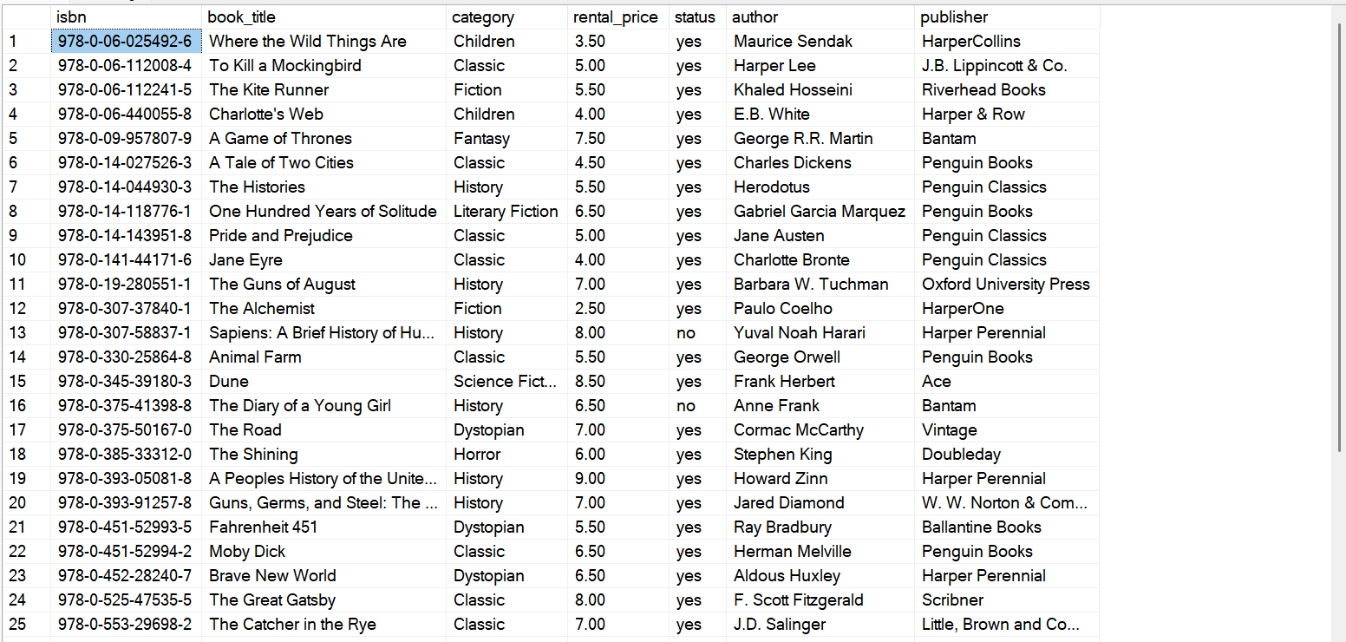

INSERT INTO books([isbn], [book_title], [category], [rental_price], [status], [author], [publisher])

VALUES ('978-1-60129-456-2', 'To Kill a Mockingbird', 'Classic', 6.00, 'yes', 'Harper Lee', 'J.B. Lippincott & Co.')

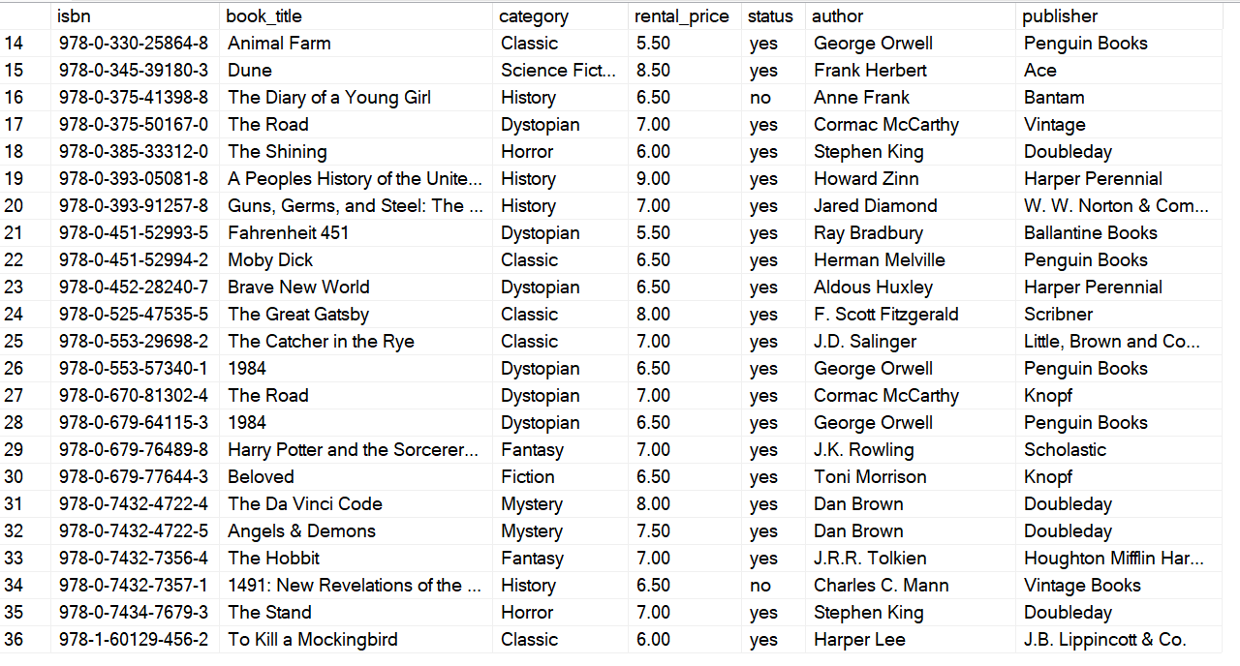

Task 2: Update an Existing Member's Address

UPDATE members

SET member_address = '125 Main st'

Where member_id= 'C101'

SELECT * FROM members

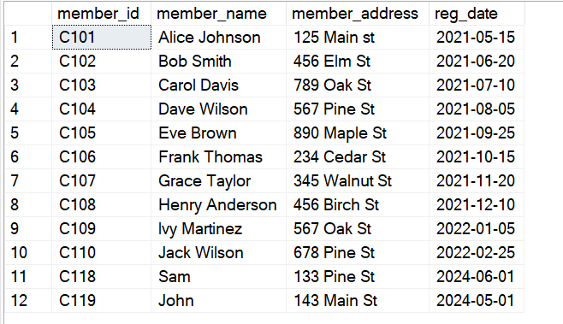

Task 3: Delete a Record from the Issued Status Table

Objective: Delete the record with issued_id = 'IS104' from the issued_status table.

Select * from issued_status-- There were 35 rows

DELETE FROM issued_status

WHERE issued_id = 'IS121';

Select * from issued_status-- Now there are 34 Rows

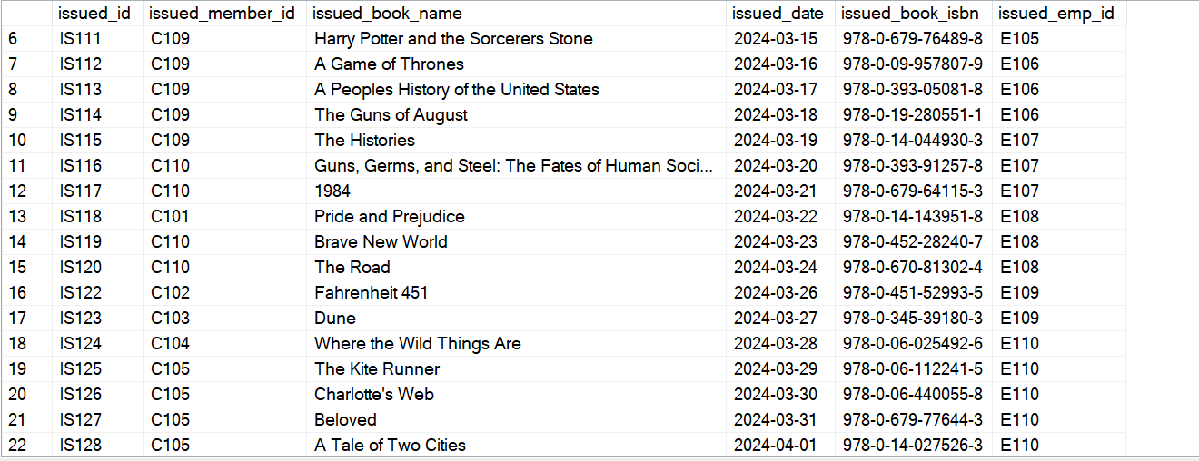

Task 4: Retrieve All Books Issued by a Specific Employee

Objective: Select all books issued by the employee with emp_id = 'E101'.

SELECT * FROM issued_status

WHERE issued_emp_id = 'E101'



Task 5: List Members Who Have Issued More Than One Book

Objective: Use GROUP BY to find members who have issued more than one book.

SELECT * FROM

(

SELECT issued_member_id, COUNT(*) AS Total_book_Issued FROM issued_status

Group by issued_member_id

)t

WHERE Total_book_Issued >1

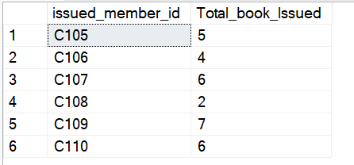

**CTAS (Create Table As Select)**

Task 6: Create Summary Tables**: Used CTAS to generate new tables based on query results each book and total book_issued_cnt

SELECT

b.isbn,

b.book_title,

COUNT(isst.issued_id) AS Total_book_Issued

INTO Total_Books_Issued_by_Each_book

FROM books as b

JOIN issued_status as isst

ON isst.issued_book_isbn = b.isbn

Group by b.isbn, b.book_title

Select * from Total_Books_Issued_by_Each_book

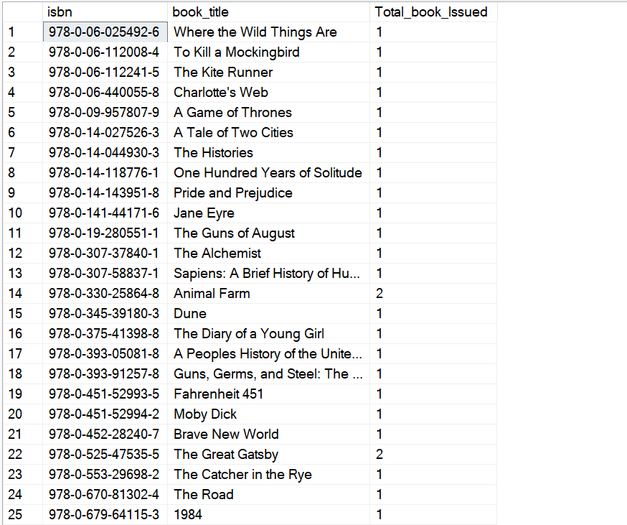

**Data Analysis & Findings**

Task 7. Retrieve All Books in a Specific Category:

Objective: Category is Classic

SELECT

category,

book_title FROM books

WHERE category = 'Classic'

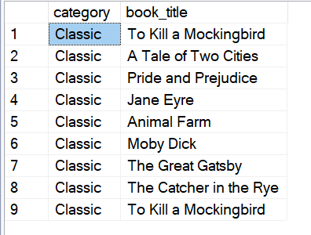

Task 8: Find Total Rental Income by Category:

SELECT

b.category,

SUM(b.rental_price) AS Rental_Income,

COUNT(*) No_of_items_sold

FROM books AS b

JOIN issued_status as isst

ON isst.issued_book_isbn = b.isbn

GROUP BY category

ORDER BY Rental_Income DESC

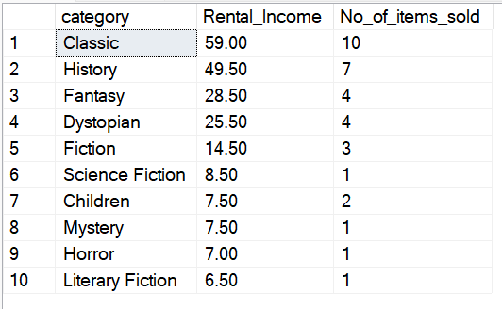

Task 9. List Members Who Registered in the Last 180 Days:

SELECT *

FROM members

WHERE reg_date > DATEADD(DAY, -300, GETDATE());

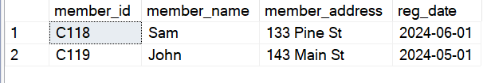

Task 10: List Employees with Their Branch Manager's Name and their branch details:

SELECT

e1.*,

br.manager_id,

e2.emp_name as Manager

FROM employees as e1

JOIN branch br

ON e1.branch_id = br.branch_id

JOIN employees e2

ON e2.emp_id = br.manager_id

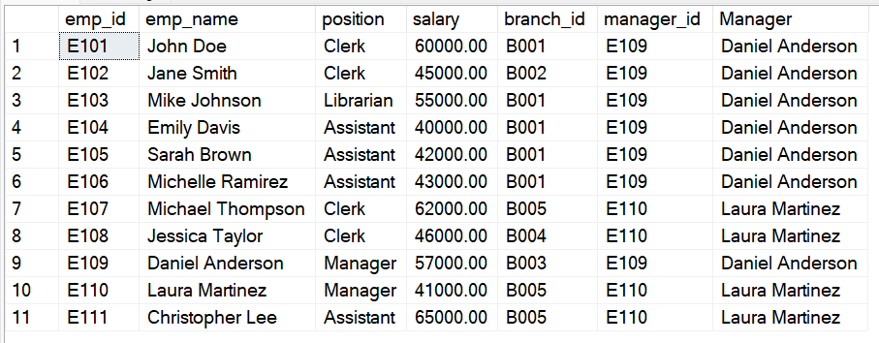

Task 11. Create a Table of Books with Rental Price Above a Certain Threshold

SELECT * INTO Books_Price_Greater_than_Seven

FROM books

WHERE rental_price > 7

SELECT * FROM Books_Price_Greater_than_Seven

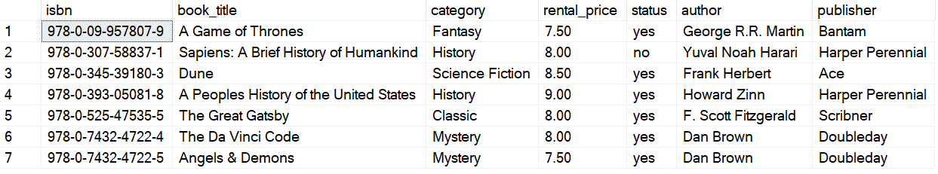

Task 12: Retrieve the List of Books Not Yet Returned

SELECT

DISTINCT isst.issued_book_name

FROM issued_status isst

LEFT JOIN [return_status ] rs

ON isst.issued_id = rs.issued_id

WHERE rs.return_id IS NULL

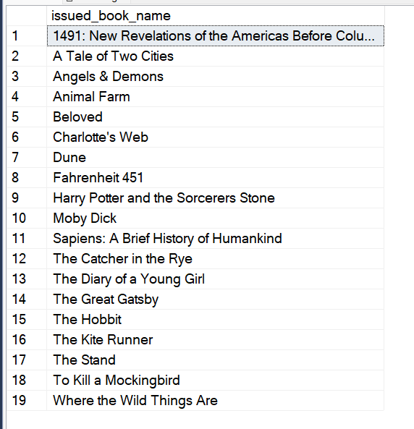

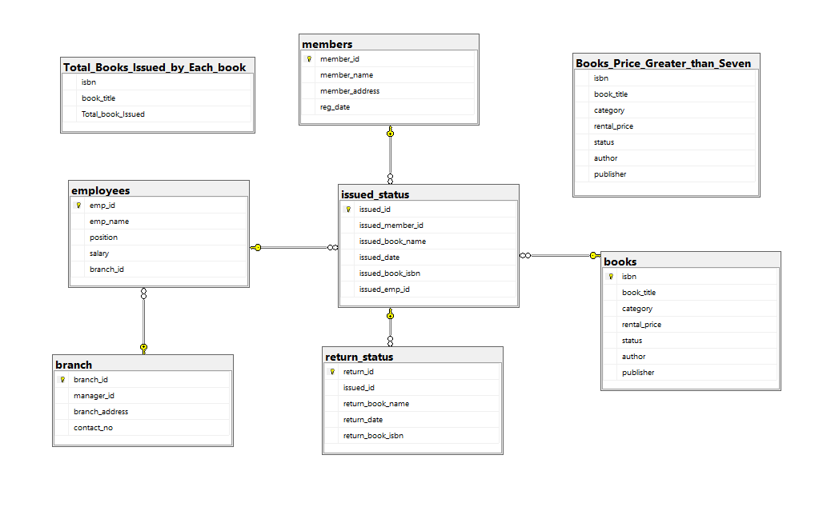

**SOME CHANGES BEFORE DOING ADVANCE SQL OPERATIONS**

-- Inserting records into issued_status table

INSERT INTO issued_status (issued_id, issued_member_id, issued_book_name, issued_date, issued_book_isbn, issued_emp_id)

VALUES

('IS151', 'C118', 'The Catcher in the Rye', DATEADD(DAY, -144, GETDATE()), '978-0-553-29698-2', 'E108'),

('IS152', 'C119', 'The Catcher in the Rye', DATEADD(DAY, -133, GETDATE()), '978-0-553-29698-2', 'E109'),

('IS153', 'C106', 'Pride and Prejudice', DATEADD(DAY, -127, GETDATE()), '978-0-14-143951-8', 'E107'),

('IS154', 'C105', 'The Road', DATEADD(DAY, -152, GETDATE()), '978-0-375-50167-0', 'E101');

SELECT * FROM issued_status

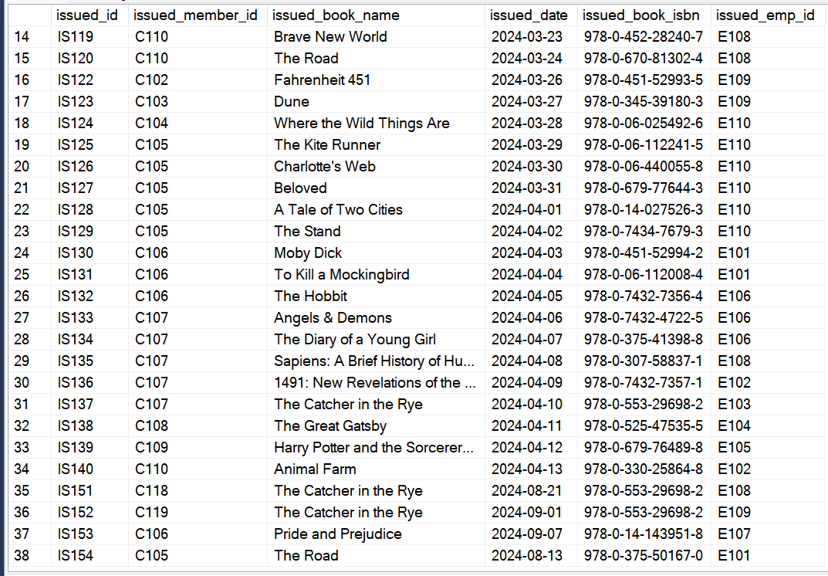

-- Adding a new column to return_status table

ALTER TABLE return_status

ADD book_quality VARCHAR(15) DEFAULT 'Good';

-- Updating the book_quality column for specific issued IDs

UPDATE [return_status ]

SET book_quality = 'Damaged'

WHERE issued_id IN ('IS112', 'IS117', 'IS118');

-- Selecting all records from return_status table

SELECT * FROM [return_status ];

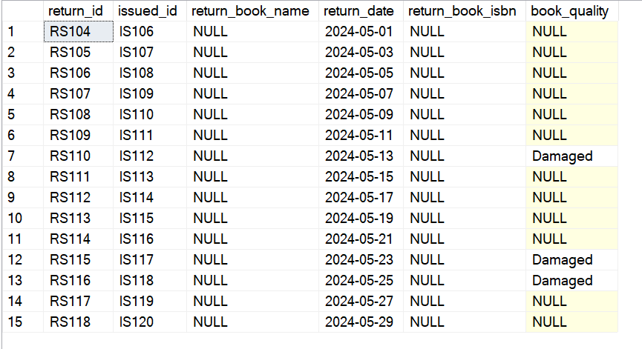

ADVANCE SQL OPERATIONS

SELECT * FROM books --36 Records

SELECT * FROM branch -- 5 Records

SELECT * FROM employees -- 11 Records

SELECT * FROM issued_status --38 Records

SELECT * FROM members -- 12 Records

SELECT * FROM [return_status ] -- 15 Records

Task 13: Identify Members with Overdue Books

Write a query to identify members who have overdue books (assume a 30-day return period). Display the member's name, book title, issue date, and days overdue.

SELECT CONVERT(date, DATEADD(MONTH, -4, GETDATE())) Todays_date_Using_Convert_and_DateADD;

-- OR

SELECT CAST(DATEADD(MONTH,-4,GETDATE()) AS date) Todays_date_Cast_and_DateADD

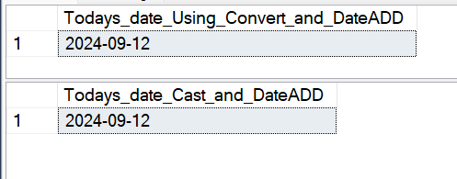

SELECT

isst.issued_member_id,

m.member_name,

b.book_title,

isst.issued_date,

--rs.return_date,

CAST(DATEADD(MONTH,-4,GETDATE())AS date) Todays_date,

DATEDIFF(DAY,isst.issued_date,

CAST(DATEADD(MONTH,-4,GETDATE()) AS date)) as Over_due_days

FROM issued_status isst

JOIN members m

ON isst.issued_member_id = m.member_id

JOIN books b

ON isst.issued_book_isbn = b.isbn

LEFT JOIN [return_status ] rs

ON isst.issued_id = rs.issued_id

WHERE

rs.return_date is NULL

AND

DATEDIFF(DAY,isst.issued_date,CAST(DATEADD(MONTH,-4,GETDATE()) AS date)) >30

ORDER BY 1

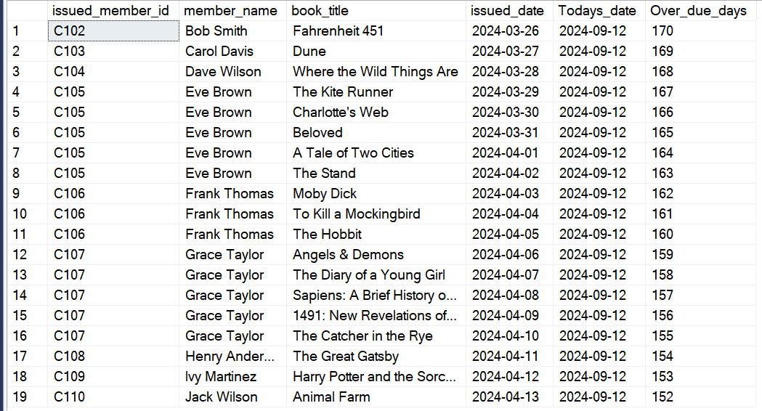

Task 14: Update Book Status on Return

Write a query to update the status of books in the books table to "available" when they are returned (based on entries in the return_status table).

Store Procedures

GO

-- Stored Procedure for SQL Server

CREATE PROCEDURE add_return_records

@p_return_id VARCHAR(10),

@p_issued_id VARCHAR(10),

@p_book_quality VARCHAR(15)

AS

BEGIN

SET NOCOUNT ON;

DECLARE @v_isbn VARCHAR(50);

DECLARE @v_book_name VARCHAR(100);

-- Inserting Records in return_status table based on user input

INSERT INTO [return_status ] (return_id, issued_id, return_date, book_quality)

VALUES

(@p_return_id, @p_issued_id, CAST(GETDATE() AS DATE), @p_book_quality);

-- Retrieving book details from issued_status

SELECT

@v_isbn = issued_book_isbn,

@v_book_name = issued_book_name

FROM

issued_status

WHERE

issued_id = @p_issued_id;

-- Updating the book status in the books table

UPDATE books

SET status = 'yes'

WHERE isbn = @v_isbn;

-- Output message for successful book return

PRINT 'Thank you for returning the book ' + @v_book_name;

END;

SELECT * FROM issued_status

SELECT * FROM [return_status ]

-- Below is the Verification that this isbn 978-0-307-58837-1 book is issued by IS135 issue_id which has 'no' status as It is not available

SELECT * FROM books

WHERE isbn ='978-0-307-58837-1'



-- Here you can see book is not returned yet

-- By whom this book is issued

SELECT * FROM issued_status

WHERE issued_book_isbn ='978-0-307-58837-1'



-- Issued_id IS135

-- Here below as You can see that no return records is there by issue_id IS135 so book is still with IS135 person

SELECT * FROM [return_status ]

WHERE issued_id = 'IS135'

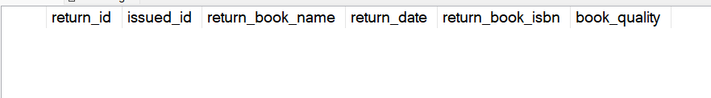

-- TESTING FUNCTION add_return_records

EXEC add_return_records 'RS119', 'IS135', 'Good';

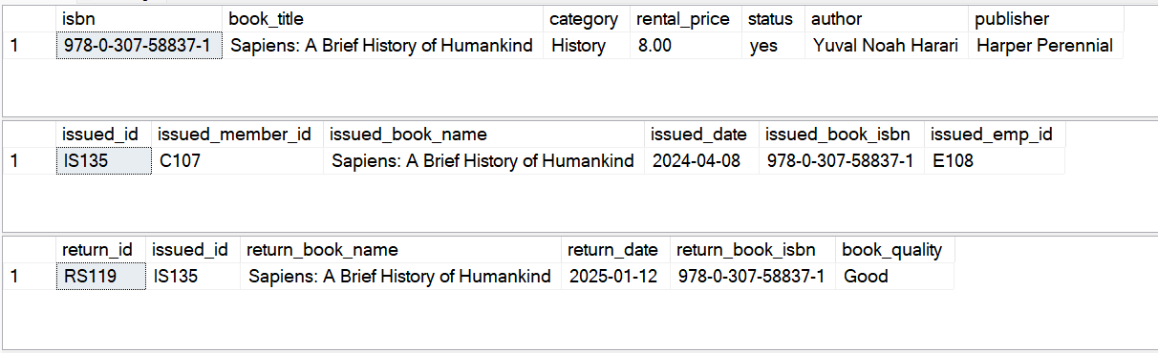

-- Testing of add_return_records procedure

--UPDATE books

--SET status ='no'

--WHERE isbn = '978-0-330-25864-8'

SELECT * FROM books

WHERE isbn ='978-0-330-25864-8'

-- Here you can see book is not returned yet



-- By whom this book is issued

SELECT * FROM issued_status

WHERE issued_book_isbn ='978-0-330-25864-8'

-- Issued_id IS140

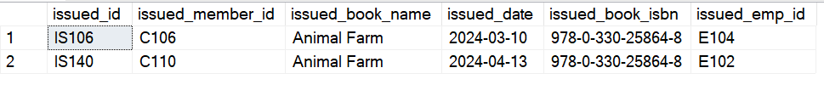

SELECT * FROM [return_status ]

WHERE issued_id = 'IS140'

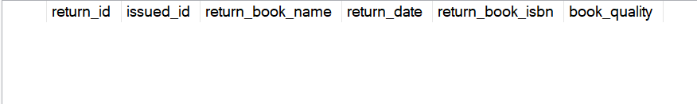

--As You can see there is no Return records of IS140

-- TESTING FUNCTION add_return_records

EXEC add_return_records 'RS120', 'IS140', 'Good';

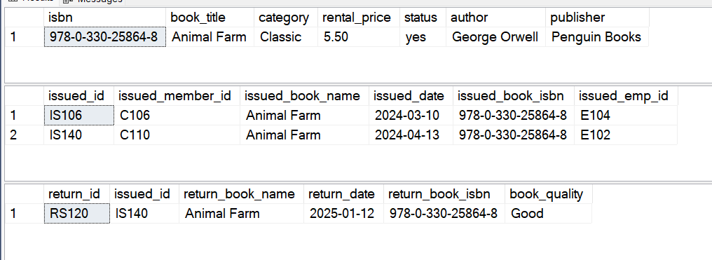

Task 15: Branch Performance Report

Create a query that generates a performance report for each branch, showing the number of books issued, the number of books returned, and the total revenue generated from book rentals.

SELECT

br.branch_id,

br.manager_id,

COUNT(isst.issued_id) Number_of_Books_Issued,

COUNT(rs.return_id) Number_of_Books_Returned,

SUM(b.rental_price) Total_Revenue

INTO Branch_Report

FROM issued_status isst

JOIN employees e

ON isst.issued_emp_id = e.emp_id

JOIN branch br

ON br.branch_id = e.branch_id

LEFT JOIN [return_status ] as rs

ON rs.issued_id = isst.issued_id

JOIN books b

ON isst.issued_book_isbn = b.isbn

Group by br.branch_id, br.manager_id

SELECT * FROM Branch_Report

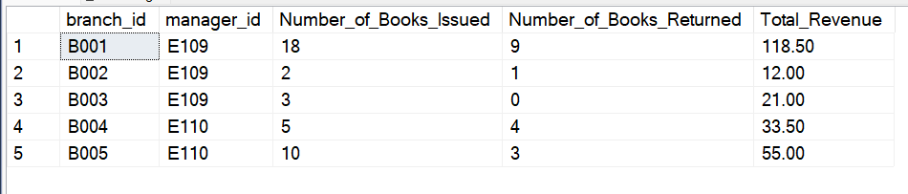

Task 16: CTAS: Create a Table of Active Members

Use the CREATE TABLE AS (CTAS) statement to create a new table active_members containing members who have issued at least one book in the last 6 months.

SELECT DATEADD(MONTH,-7,CAST(GETDATE() AS date)) Todaysdate

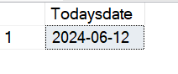

SELECT *,

DATEADD(MONTH,-7,CAST(GETDATE() AS date)) Todaysdate

FROM issued_status

WHERE issued_date > DATEADD(MONTH,-7,CAST(GETDATE()as date))

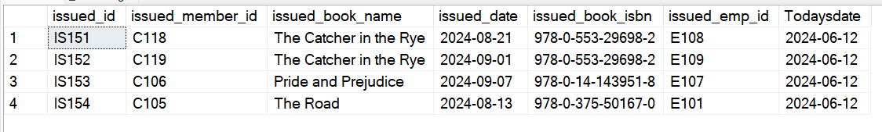

SELECT DISTINCT issued_member_id

FROM issued_status

WHERE issued_date > DATEADD(MONTH,-7,CAST(GETDATE()as date))

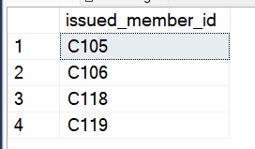

SELECT * INTO Active_Members FROM members

WHERE member_id IN

(

SELECT DISTINCT issued_member_id

FROM issued_status

WHERE issued_date > DATEADD(MONTH,-7,CAST(GETDATE()as date))

)

SELECT * FROM Active_Members

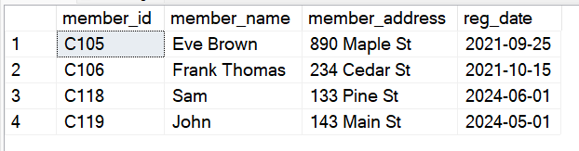

Task 17: Find Employees with the Most Book Issues Processed

Write a query to find the top 3 employees who have processed the most book issues. Display the employee name, number of books processed, and their branch.

SELECT TOP 3

e.emp_name,

br.branch_id,

br.manager_id,

branch_address,

contact_no,

COUNT(isst.issued_id) Number_of_book_issued

FROM issued_status isst

JOIN employees e

ON e.emp_id = isst.issued_emp_id

JOIN branch br

ON e.branch_id = br.branch_id

GROUP BY

emp_name,

br.branch_id,

br.manager_id,

branch_address,

contact_no

ORDER BY COUNT(isst.issued_id) DESC

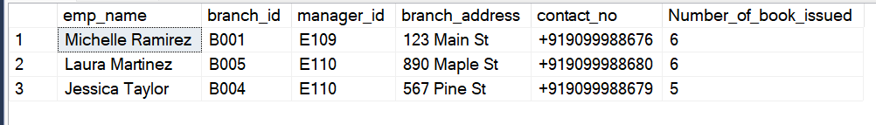

Task 18: Identify Members Issuing High-Risk Books

Write a query to identify members who have issued books more than twice with the status "damaged" in the books table. Display the member name, book title, and the number of times they've issued damaged books.

SELECT

m.member_name,

isst.issued_book_name,

COUNT(isst.issued_id) Number_of_time_issued_book

FROM issued_status isst

JOIN members m

ON isst.issued_member_id = m.member_id

LEFT JOIN [return_status ] rs

ON rs.issued_id = isst.issued_id

WHERE

rs.book_quality = 'Damaged'

GROUP BY

m.member_name,

isst.issued_book_name

Task 19: Stored Procedure

Objective: Create a stored procedure to manage the status of books in a library system.

Description: Write a stored procedure that updates the status of a book based on its issuance or return. Specifically:

If a book is issued, the status should change to 'no'.

If a book is returned, the status should change to 'yes'.

GO

CREATE PROCEDURE issue_book

@p_issued_id VARCHAR(10),

@p_issued_member_id VARCHAR(30),

@p_issued_book_isbn VARCHAR(50),

@p_issue_emp_id VARCHAR(10)

AS

BEGIN

DECLARE @v_status VARCHAR(10);

DECLARE @v_book_title VARCHAR(100);

-- Check if the book is available

SELECT @v_status = status,

@v_book_title = book_title

FROM books

WHERE isbn = @p_issued_book_isbn;

-- Handle case where the book is not found

IF @v_status IS NULL

BEGIN

PRINT 'No book found with the provided ISBN: ' + CAST(@p_issued_book_isbn AS VARCHAR);

RETURN;

END;

-- Check if the book is available

IF @v_status = 'yes'

BEGIN

-- Insert the issued book record

INSERT INTO issued_status (issued_id, issued_member_id, issued_date, issued_book_name, issued_book_isbn, issued_emp_id)

VALUES (@p_issued_id, @p_issued_member_id, CAST(GETDATE() AS DATE), @v_book_title, @p_issued_book_isbn, @p_issue_emp_id);

PRINT 'Book record added successfully for book ISBN: ' + CAST(@p_issued_book_isbn AS VARCHAR);

-- Update the book status to 'no'

UPDATE books

SET status = 'no'

WHERE isbn = @p_issued_book_isbn;

END

ELSE

BEGIN

PRINT 'Sorry to inform you, the book you have requested is currently unavailable. Book ISBN: ' + CAST(@p_issued_book_isbn AS VARCHAR);

END

END;

GO

SELECT * FROM books

SELECT * FROM issued_status

EXEC issue_book 'IS155','C108','978-0-06-112008-4','E104'

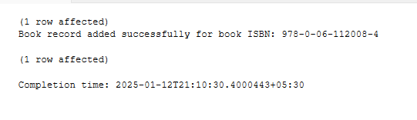

SELECT * FROM books

WHERE isbn = '978-0-06-112008-4' -- status yes



SELECT * FROM issued_status

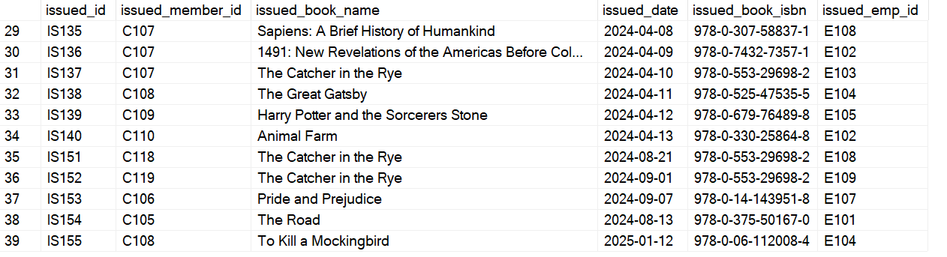

-- Now this book is issued for some now if we another book or suppose this book is issued by some one then

EXEC issue_book 'IS155','C108','978-0-06-112008-4','E104'

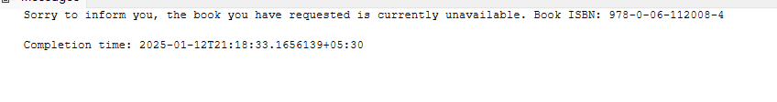

Task 20: Create Table As Select (CTAS)

Objective: Create a CTAS (Create Table As Select) query to identify overdue books and calculate fines.

Description: Write a CTAS query to create a new table that lists each member and the books they have issued but not returned within 30 days. The table should include:

The number of overdue books.

The total fines, with each day's fine calculated at $0.50.

The number of books issued by each member.

The resulting table should show:

Member ID

Number of overdue books

Total fines

*/

SELECT

m.member_id,

m.member_name,

COUNT(isst.issued_id) AS Number_of_Overdue_books,

COUNT(isst.issued_id) * 0.50 AS Total_Fines

INTO Overdue_books_And_Fines

FROM issued_status isst

JOIN members m

ON isst.issued_member_id =m.member_id

LEFT JOIN [return_status ] rs

ON rs.issued_id = isst.issued_id

JOIN books b

ON b.isbn = isst.issued_book_isbn

WHERE

return_date > DATEADD(DAY,30,issued_date)

GROUP BY

m.member_id,

m.member_name

SELECT * FROM Overdue_books_And_Fines

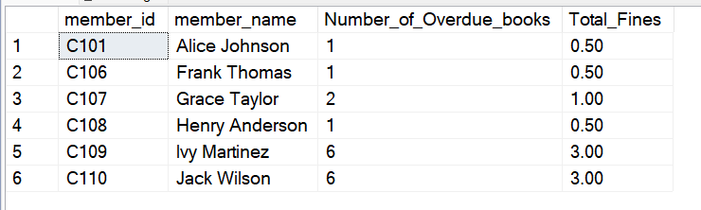

**Final ER Diagram of this Project**

